The Construction of
The Continental Army Hunting Shirt
Circa 1775-1783
by N.T. Hurst
(adaptations for 2nd SC Regiment in red)
If there were one distinct uniform for the Continental Army during the American War of Independence, many historians would immediately point towards the hunting shirt. This garment has several distinctive features:
• Construction based on a man’s shirt from the 18th Century.
• Caped around the neck edge.
• Split up the center front.
• Fringe adorning all of its edges.
The shirts that were worn specifically by army also tended to have certain attributes unlike civilian ones. Due to often shortages of material and also practicality, many of the hunting shirts were cut very short. On April 3rd 1776, the 6th Virginia Orderly Book from Williamsburg, Virginia notes “The captains of the 6th Battlaion, together with the other Officers are immediately to provide themselves with Hunting Shirts, short and fringed.” Later in September the same orderly book will record that “…a hunting shirt well made and short just to come below the waistband of the breeches….”
Another option seen on both military and civilians shirts is the pleated for arms. Of the four surviving hunting shirts, 3 of them all illustrate this trend. This can also be seen in various period paintings, illustrations, and descriptions.
The following instructions will help one construct a hunting shirt based on a surviving example in Pennsylvania. With some small minor changes, it will reflect the type of shirt being received and used by the Continental Army.

Materials:
The average person requires THREE yards for a split shirt. The most common material listed for hunting shirts in this period for the army is osnaburg, or a coarse natural linen. This is a medium weight unbleached linen. This can easily be obtained through the following sources:
Best Choice: #4C22 (Natural, softened) from Fabrics-store.com
Acceptable Choices: #5610 from Burnley & Trowbridge
#WLG 102 from William Booth Draper
Oznaburg Linen from Najecki Reproductions
#WLG 101 from William Booth Draper (heavy-weight fabric, same as used for 2SC smallclothes)
Hunting shirt kits are also available from Neal Hurst: kneelhurst@yahoo.com

Parts:
NOTE: All pieces should be cut by pulling threads, creating a perfect straight edge!
Everything listed includes ½” seam allowance:
- Shoulder Strap: 10” X 5”
- Sleeves: 22” X 22” (Note: When cutting the sleeves place on edge along the selvage)
- Underarm Gusset: 5” X 5”
- Cape: (see attached pattern)
- Wristbands: (measure your wrist add 2 inches) x 3”
- Body: 27” wide X (measure to just under the butt double it and add 1 inch.)
- Fringe: Several lengths of fabric cut by pulling threads at 2” wide.

Making of the Body:
1. Lay the body out and fold in half. The fold should be at the top where the neck will go.
2. Cut up the center front of one panel.
3. On the fold at the top, make a cut across the shoulders to within 3 inches from the side seam
4. Hem center front edges.
5. Back stitch the side seams and fell them. Leave 11 inches of space on the upper part of the side seam to allow for the setting of the sleeve. Repeat on both sides.

Making of the Shoulder Straps:
1. Take the shoulder straps (two 10in X 5in pieces). Press back 1/2inch on each of the long sides.
2. Center the strap over the shoulder. Spread the cut fabric to meet the ends of the strap along the neck edge. This will make the opening wider for the neck without the use of a separate gusset.
3. Pin in place
4. Back stitch in place
5. On the interior of the shirt herringbone stitch the raw cut edges to the underside of the shoulder strap.
6. Baste back 1/2 inch around the arm opening.
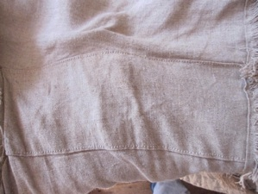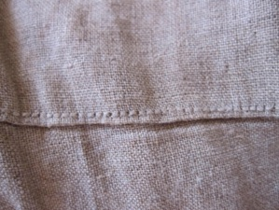
Exterior View of Shoulder strap Stitching to hold shoulder strap in place

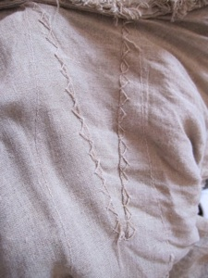

Underside of Shoulder Strap, showing Herringbone stitches.

Making of the Sleeves:
1. Take one of the sleeve pieces. Place the under arm gusset on the edge below the selvage. The selvage edge will be the end that is stitched into the body
2. Stitched the underarm gusset in place.
3. Take the other side of the sleeve matching up and creating the underarm gusset.
4. Sew the entire length of the sleeve stopping 4 1/2 inches from the edge where the gathers for the wristband will go.
5. Fell all the seams and hem the vent at the wrist.

Gathers:
1. 1/4 inch down from the raw edge, place a running stitch every 5-7 threads. Repeat this 1/4 below, created two parallel lines.
2. Mark with a tailor tack the center of the sleeve.
3. Pull gathers tight.
4. Repeated on other sleeve.

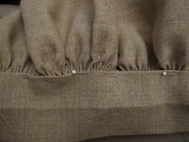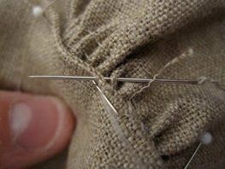

Arranging and Sewing gathers.

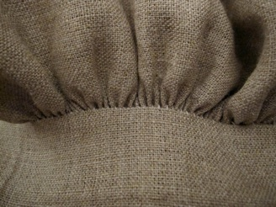

Finished gathers.

Wristbands:
1. Press back all the seam allowance.
2. Repeat on wristband.

Putting Wristbands on the Sleeves:
1. Pin both ends of the wristband to the sleeve. It helps to anchor the gathering threads with pins
2. Spread gathers out equally.
3. Begin whip stitching from the front side, stitching each gather individually in place. (Each one in stabbed and stitched into the fold of the seam allowance of the wristband. This takes time and patience!)
4. Once the front is done, repeat on the interior side.
5. Whip up the sides of the wristband to close them
6. Repeat on the other wristband.
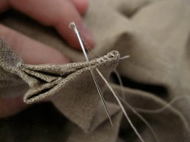 Closing sides of wristbands. 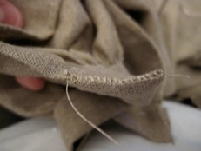

Gathers on Sleeves:
1. From the bottom of the underarm gusset, measure 8 inches on each side. Mark with a tack.
2. Between those marks, run gathering stitches as described for the sleeve.
3. Mark the top of the sleeve with a tailors tack
4. Pull tight
5. Repeat on second sleeve.
Setting Sleeves:
1. Working from the exterior of the shirt, slip the sleeve into the arm opening. Pin under arm gusset up to the gathers flat.
2. Spread the gathers out evenly as possible. It helps to anchor the gathering threads with pins.
3. Whip stitch the sleeve in from exterior. When you get to the gathers, stitch each one individually to the folded edge.
4. Repeat on the other sleeve
5. From the inside, fell just the underarm gusset edge leaving the sleeve unfinished.

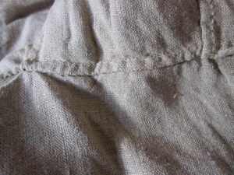
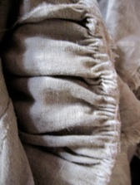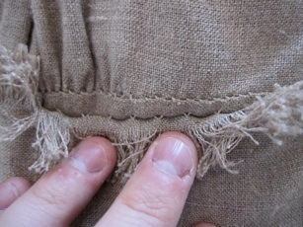
Felled section of the gusset. Interior of sleeve left raw. Stitches attaching the sleeve to the body.

Cape:
1. Take the cape and match up the ends with the center front from the INTERIOR of the shirt. There should be little to no ease around the cape.
2. Do not hem the cape.
3. Back stitch the cape around the neck edge.
4. Flip the cape out to the exterior and press.
5. The raw edge will be covered by the cape, and it is left raw.
Fringe:
1. Take 2 inch wide lengths of fabric cut by pulling threads. Press in half.
2. Fringe down center front, hem, cape edge, neck edge (through body and cape) and around the arm opening. NOTE: arm opening fringe optional for 2nd SC
3. This is placed on by running stitching on the folded edge or a spaced back stitch along that edge.
4. Pull fringe once it is all on.
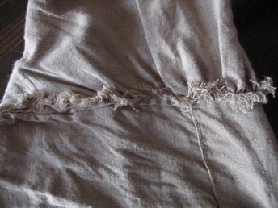

Sleeve showing Fringe.

Finishing:
1. Button holes in the wristbands (for either buttons or sleeve buttons)
Details:
1. 3 out of the 4 surviving hunting shirts have no fastening device at the neck; one shirt has a button and loop.
2. 2 of the 4 surviving hunting shirts have patch pockets stitched in the interior of them.
3. 3 out of the 4 surviving hunting shirt has pleated forearms. If you wish to do this, a row of fringe will be applied midway up the sleeve.
4. One of the surviving shirts shows evidence of 3 ties closing it up the center front.
FOR 2ND SC: one pewter button and loop at the neck, patch pockets optional (keep them beneath cross belt area), pleated arms optional, no ties in front
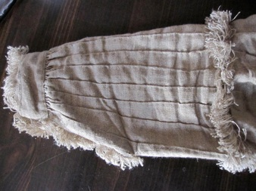
Finished sleeve showing pleated forearms and fringe.
Images of Completed Hunting Shirt.
